INSTALLATION GUIDE


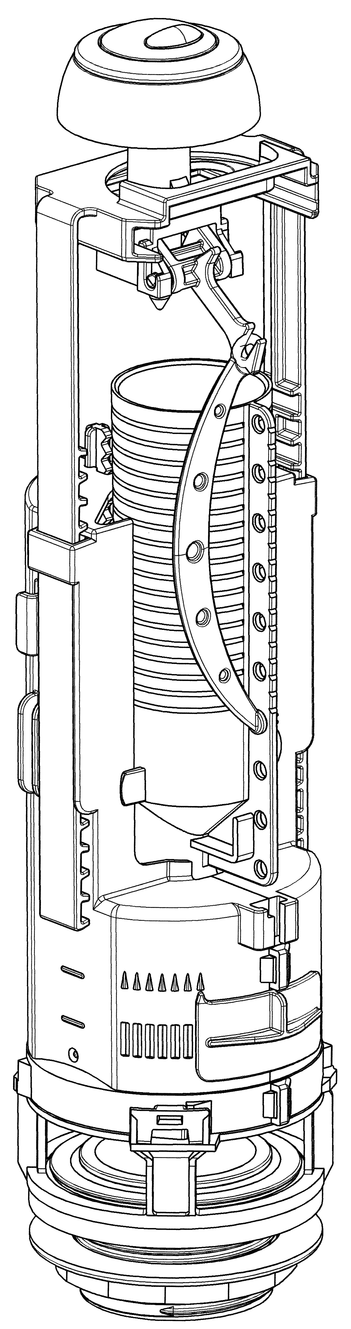

ADVICE
Dual Flush Outlet Valve

OPTIMA 49

Keep these instructions safety for any maintenance operations

Before you start:
- Read these instructions carefully.
- Check the pack and make sure you have all the parts on the pack list.
- Remove all packaging from pottery and check for surface damage or defects.
- Prepare a firm working surface (e.g: floor or bench) for cistern assembly, covering work surface with cloth to prevent scratching the glazed faces of the cistern.

1/ PARTS and FITTINGS SUPPLIED

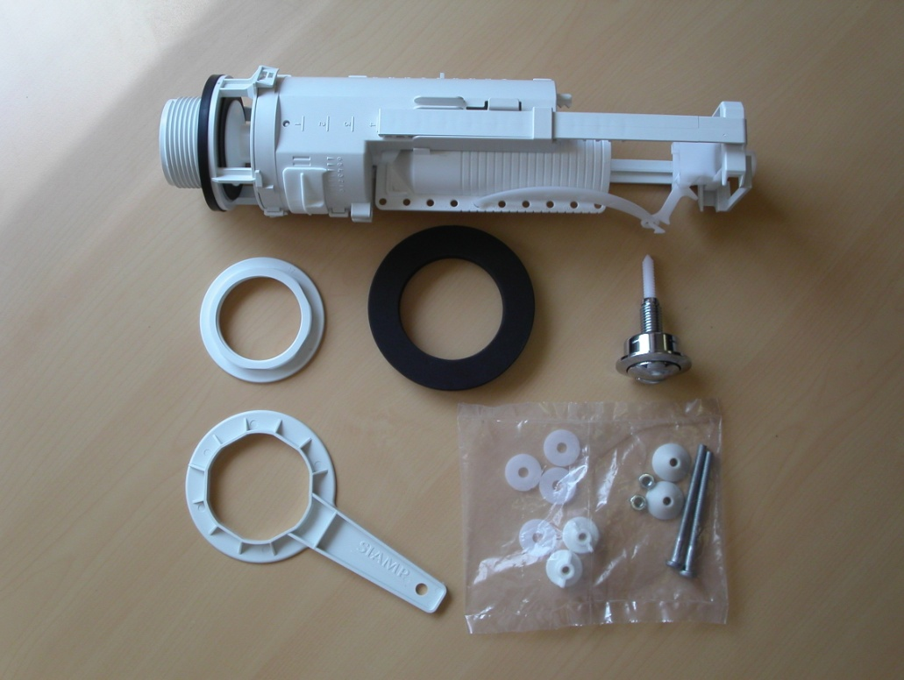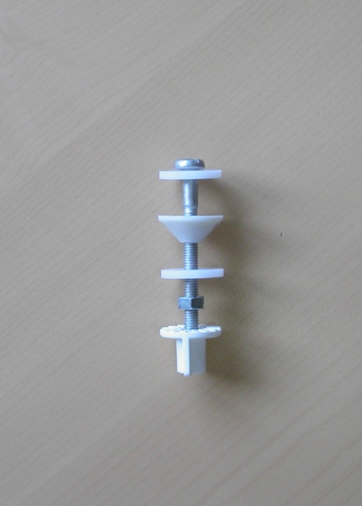

H

K

J

G

I

F

E

D

C

B

A
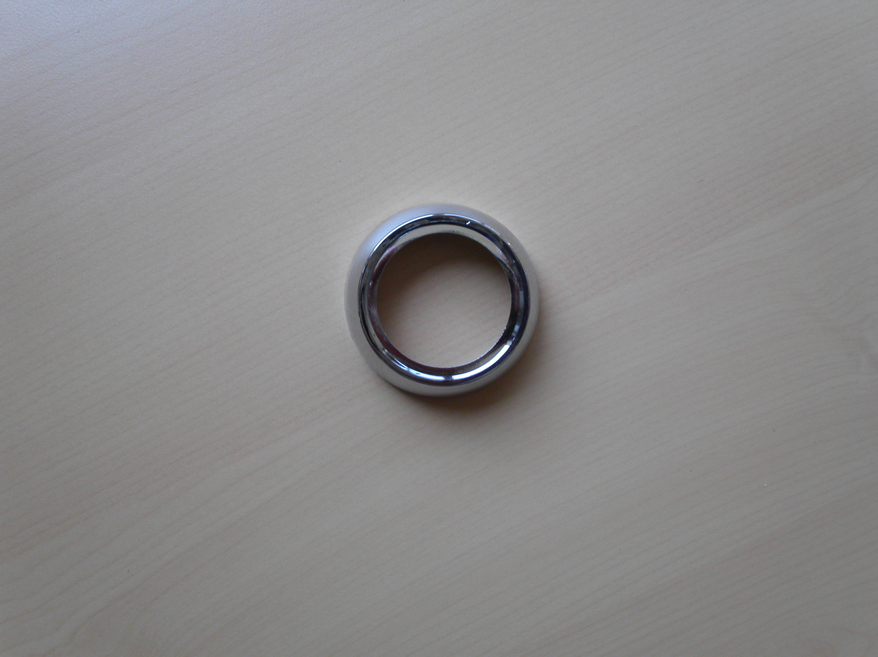

A Pushbutton G Slotted Screw (x2)
B Valve Body H Sealing Washer (x2)
C Socket Seal I Plastic Washer (x4)
D Socket Nut J Nut (x2)
E Spanner (on demand) K Butterfly nut (x2)
F Sealing Gasket L Rosette (on demand)

L

Tools required (not supplied): Slotted screw driver, fine tooth saw
and wrench 6 mm

2/ ADJUSTMENT OF VALVE HEIGHT

Measure diameter D of cover hole
Measure height H from cover top to cistern bottom.
In the table below, choose the right level for the stirrup

11

10

9

8

7

6

5

4

3

2

1

Cistern height H |  | Stirrup visible adjustment rung
Diameter of lid hole from 18 to 38 mm and 45 to 50 mm | Diameter of lid hole from 38 to 44 mm
430 to 417 | 448 to 435 | 11
416 to 405 | 434 to 423 | 10
404 to 393 | 422 to 411 | 9
392 to 381 | 410 to 399 | 8
380 to 369 | 398 to 387 | 7
368 to 357 | 386 to 375 | 6
356 to 345 | 374 to 363 | 5
344 to 333 | 362 to 351 | 4
332 to 321 | 350 to 339 | 3
320 to 309 | 338 to 327 | 2
308 to 297 | 326 to 315 | 1
296 to 282 | 314 to 300 | Mini
11

10

9

8

7

6

5

4

3

2

1

NB: For low cisterns, adjustment may be done on mark mini, 1, 2. 3. To move freely overflow tube require shortening, cut the excess length using a fine tooth saw.
Stirrup adjustment rung | Overflow tube shortening
3 | C mark visible
2 | F mark visible
1 | I mark visible
Mini | L mark visibleI

2/ ADJUSTMENT OF VALVE HEIGHT(continuation)

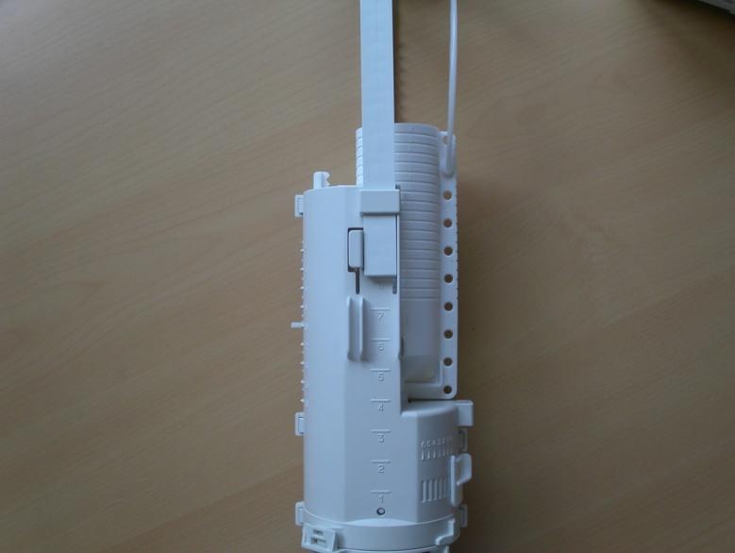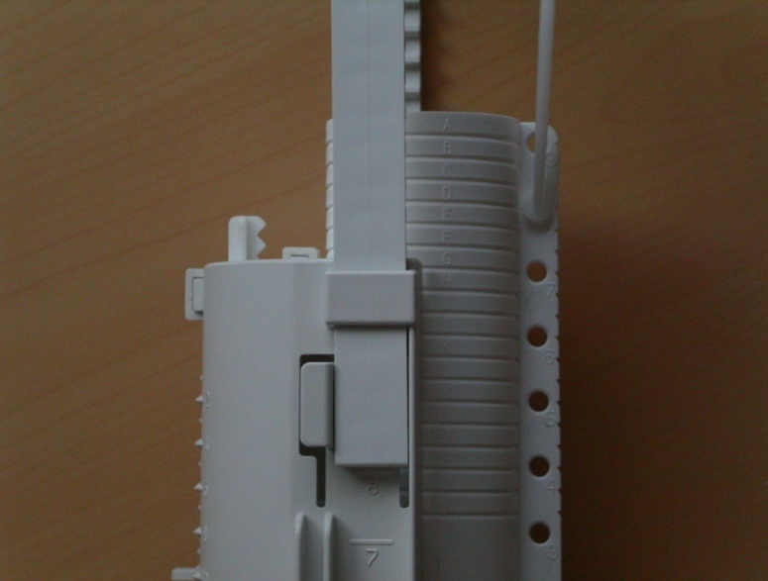

1

2

3

x

To adjust: Unclip rod (1), Press both side of enclosure (2) and slide stirrup up or down (3) to its right position. Note the level number (x) and click rod back to overflow tube at the same number(x)

3/ ASSEMBLING THE OUTLET VALVE

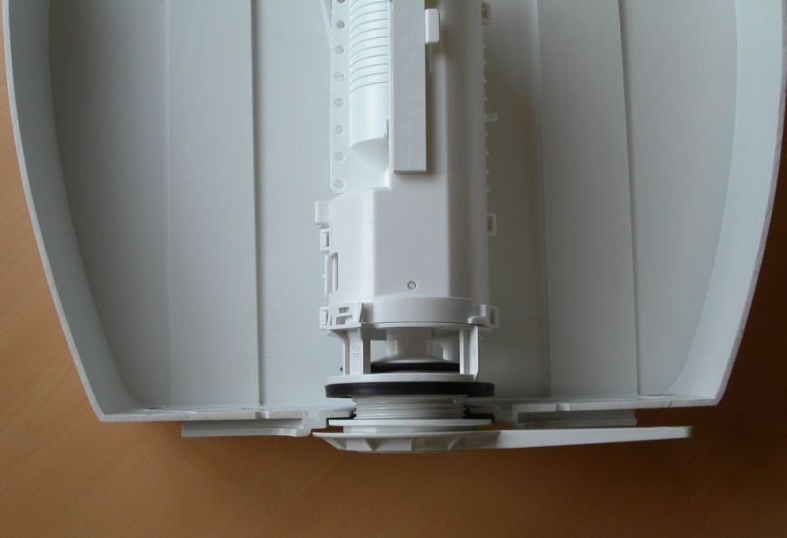
1/ Assemble the valve body B through cistern with socket seal C on inside of the cistern.
2/ Secure socket nut D with the spanner E. When tightening hold internal base of valve to ensure its position is not altered. Do not over tighten, no more than ¼ turn beyond hand tight

E

C

B

D

4/ ASSEMBLING CISTERN TO PAN

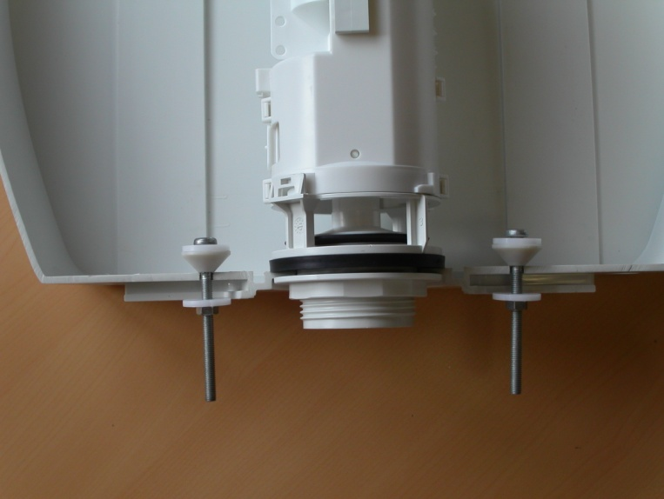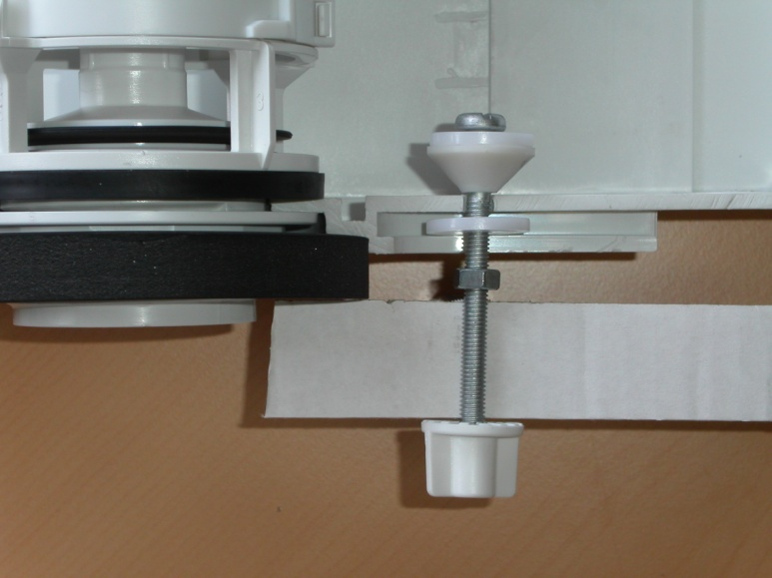

Cistern

WC back plate

Slide slotted screw G through plastic washer I and sealing washer H, then place trough cistern and secure with washer I and nut J using a 6 mm wrench. Slide sealing gasket F over socket nut. Slide cistern onto WC back plate by locating screws through WC. Secure using butterfly nut K.

5/ ASSEMBLING THE INLET VALVE

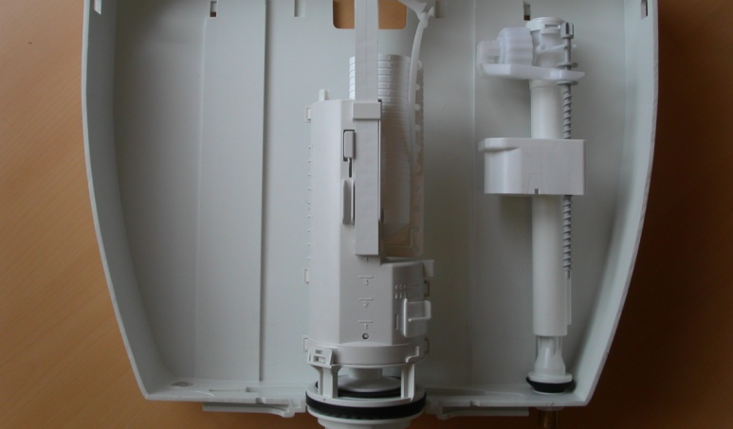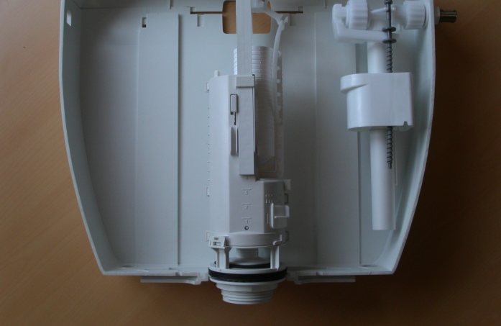
B
A

A: Bottom inlet valve
Place inlet valve through inlet hole with inlet rubber washer inside the cistern. Secure with back nut but ensure float moves freely up and down valve body.

B: Side inlet valve
Place inlet valve through inlet hole with plastic washer inside the cistern. Secure with back nut but ensure float moves freely up and down valve body.

6/ CONNECT TO WATER SUPPLY

Leak tightness is obtained by using a fibre seal. Do not use sealing compound

7/ SETTING FULL FLUSH

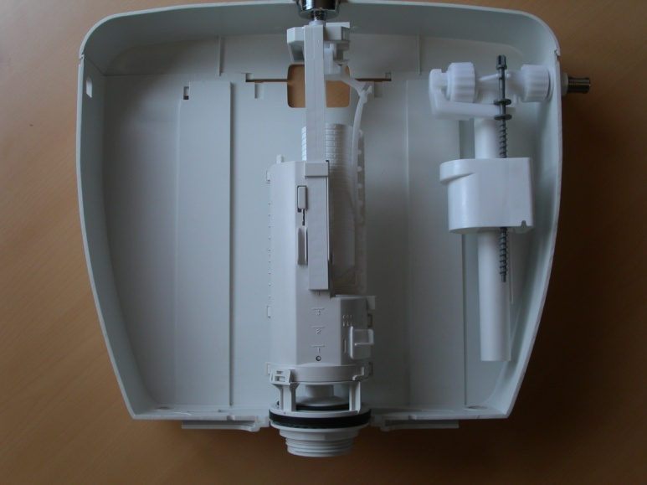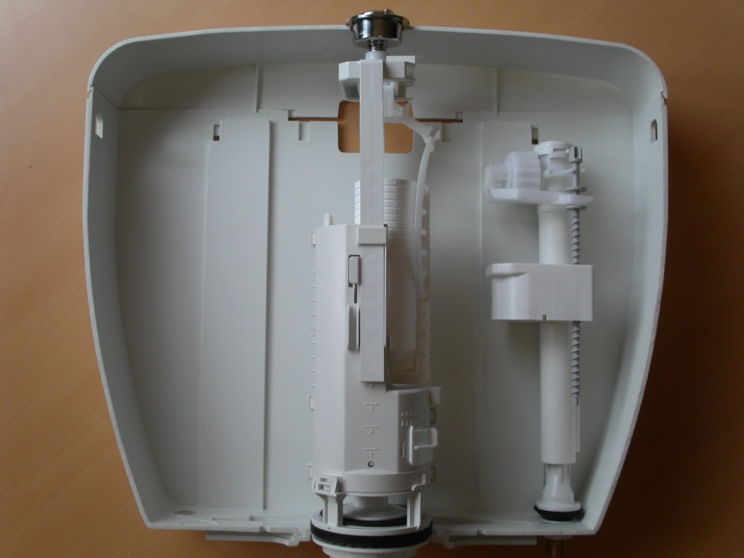

Water level

Over flow level
A
20 mm

Turn on water. Allow cistern to fill and by tightening or loosening the adjustment screw A on the inlet valve, set water level for full flush. Beware that you respect a safety level (20 mm water clearance= French Standards NF)

8/ SETTING SMALL FLUSH

1
3
5
7
9
11
13
15
17
2
4
6
8
10
12
14
16
18
To adjust small flush , move cursor A up or down.
(mark 18 is maxi, mark 1 is mini).
To work properly cursor should be immerged by 40 mm
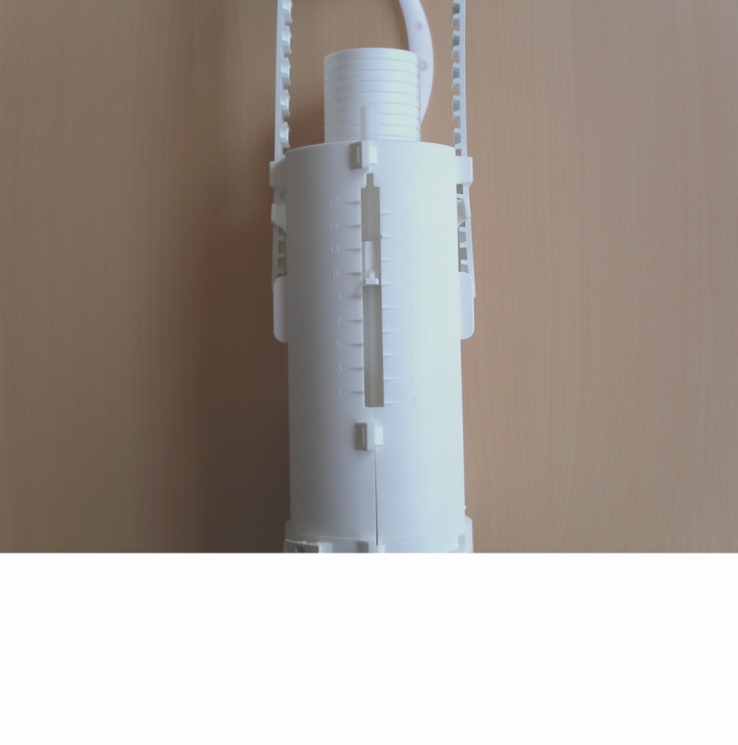

A
Mark 1
Mark 18

9/ SETTING DEAD WATER LEVEL
To ensure a forceful washing, it may be necessary to get more dead water remaining into the cistern. To increase this level slide obturator A from right to left. (mark 0 is mini, mark 5 is maxi)
Increasing the dead water level decreases the volume of flush. If necessary adjust once more (cf sections 7 and 8)

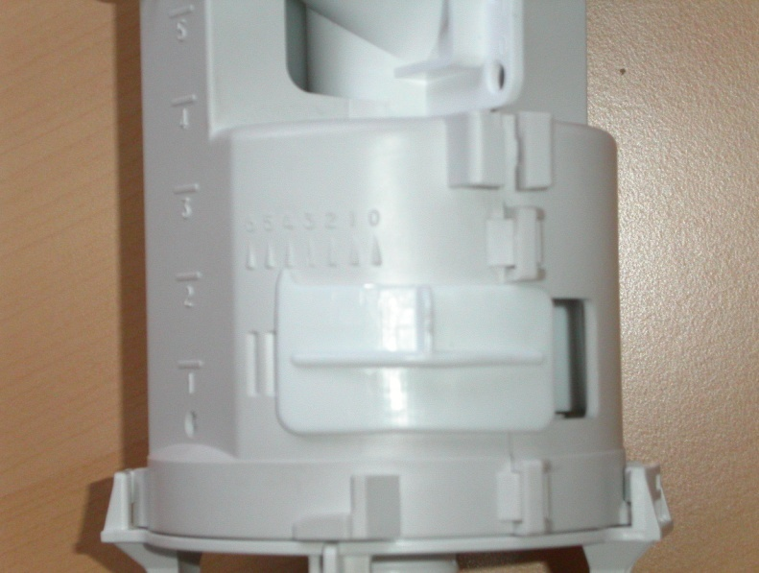
543210
A

10/ ASSEMBLING THE BUTTON

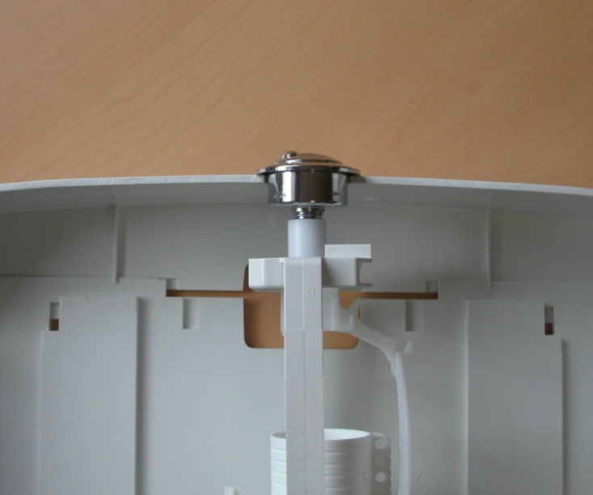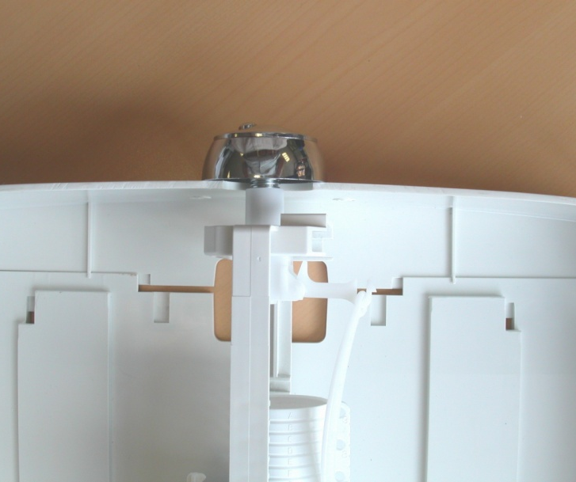
L
A

Place lid back on top of cistern. Check that lever bearing A is in front of lid hole and gently screw the button down without pushing the central part.
Use rosette L when lid hole diameter is less than 38 mm.

MAINTENANCE

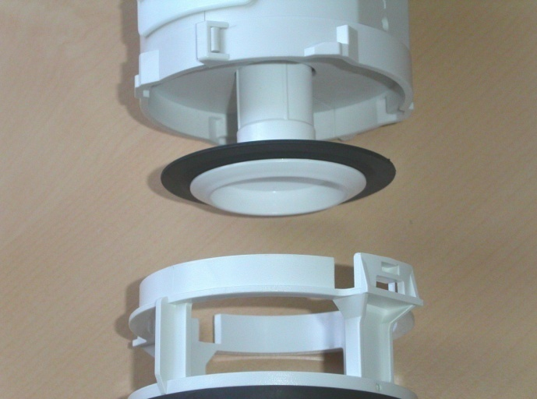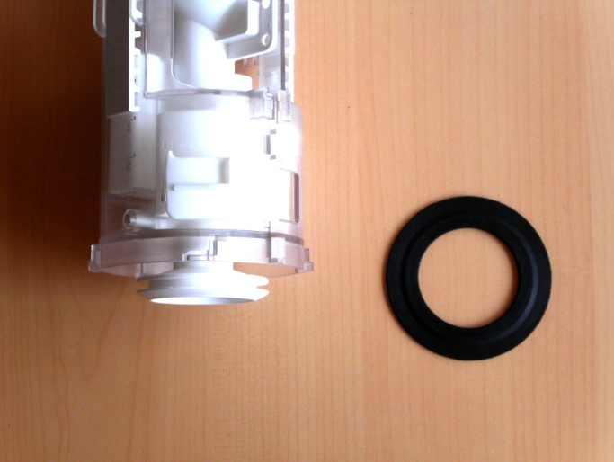
Valve P58
Ref : 344905

After a few years, depending on the nature of local water, the valve P 58 may require to changed. To access the valve, turn off water inlet, flush toilet to empty cistern, unscrew pushbutton by winding anti clockwise, remove it, lift cistern lid, unclick body of outlet valve by turning it ¼ turn counter clockwise. Replace valve, turn on water supply and check for leaks into bowl. When maintenance is over, repeat all the steps in the opposite order.

CUSTOMER GUARANTEE

You have just installed a flushing device forming a part of the SIAMP range and we would like to thank you for your confidence in our products. As expert in technical equipment and accessories for the toilet, SIAMP has taken every possible measure to apply all the necessary care to design and manufacturing of this product, offering a ten year guarantee except for rubber parts and man power.
For any complementary information, or indicated claim, please contact your dealer or SIAMP directly:

Phone 00.377.93.15.53.75, E-mail: contact@siamp.com

Due to continuing product development we reserve the right to amend technical details without prior notice

